**Complex networks visualization library**

1. **pajek software:**

* Introduction:

Pajek is a program package for analysis and visualization of large networks (networks containing up to one billion of vertices, there is no limit—except the memory size—on the number of lines). It has been available for 20 years. The program, documentation and supporting material can be downloaded and used for free for noncommercial use from its web page: <http://mrvar.fdv.uni-lj.si/pajek/>

* The Specifications of the latest version

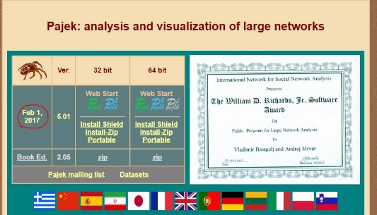

* Examples of networks drawn with this software

Fig. 1. Graphs are called bipartite networks

Fig. 2. graphs are HDN (human disease network) and DGN (disease gene network)

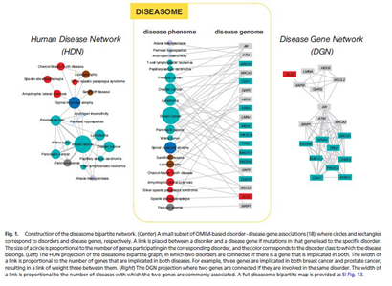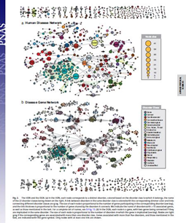

* Link to two Full-Text Articles

<http://www.pnas.org/content/104/21/8685.full>



<https://casmodeling.springeropen.com/articles/10.1186/s40294-016-0017-8>

